# Sporty-Shoes-Store

This project aims to design and develop an E-commerce Website for Sporty Shoes using Java Spring MVC. It enables users to buy and search the available products and make admin to manage the store within the system. It was developed as a project of Phase-3 for the Implement Frameworks the DevOps way Course. Sprints and Tasks.

## Product Backlog:

1. Create database and tables.
2. Add all dependencies to the Maven project.
3. Connect the database to the project.
4. Create the models’ classes.
5. Create the data access object classes using Hibernate.
6. Create login and register pages.
7. Show all products to the home page.
8. Add products to the cart.
9. Show user’s cart.
10. Create user’s update page.
11. Enable the admin to add a new product.
12. Enable the ability to search for a specific product.
13. Make the admin able to update and remove a product.
14. Make the admin manage the users.

## Flowcharts of The Application

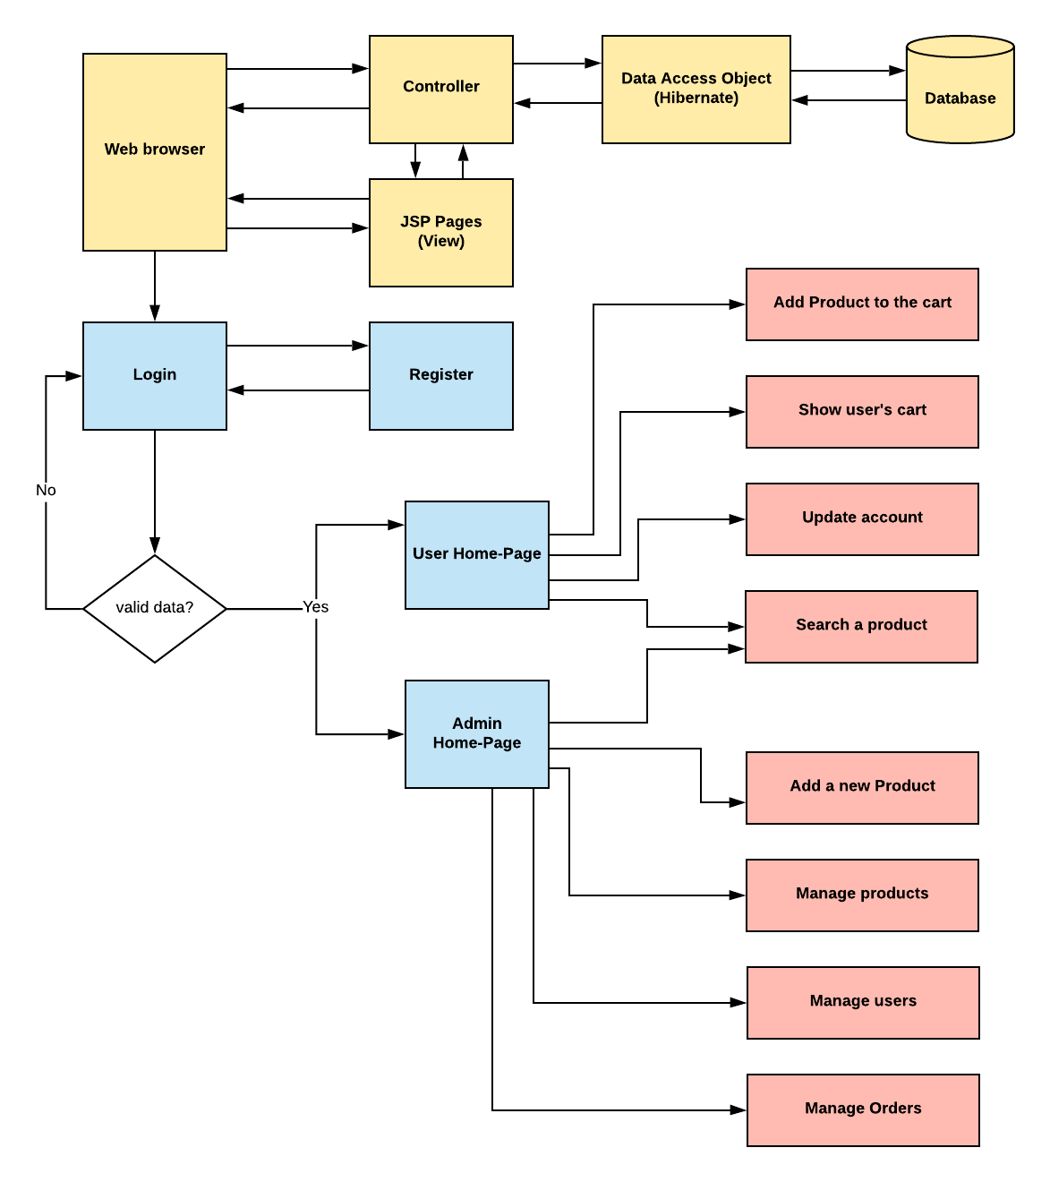

## Technologies and tools Used

• Spring MVC: to build web applications as it follows the Model-View-Controller design pattern.

• JSP: to handle the presentation view.

• Hibernate: to simplify the development and the interaction with the database.

• Maven: to manage the project.

• Eclipse: to write and run the code.

• Tomcat: to run and deploy servlet application.

## Core concepts used in the project

• Object-Oriented: used to create and model objects for users and their credentials.

• Data Access Object: to abstract and encapsulate all access to the data source.

• Object–Relational Mapping: to map the objects to the database.

• Databases: used to store and retrieve data.

• Data Sources: used to define a set of properties required to identify and access the database.

• Collections: used some collections such arraylist to store collection of data.

• Exception Handling: used to catch problems that arises in the code especially in I/O blocks

## Screenshots

